GitHub Repository – NovaTech Computer Solutions

Repository Link
arshad-gaj/ST10474894-ARSHAD-GAJ-POE-PART-1: WEDE5020 POE Part 1 - NovaTech Computer Solutions Website
The repository contains the six HTML5 pages, website image assets and README documentation. Separate descriptive commits were used to record the development of the website through different stages.

GitHub Repository and Version Control
GitHub was used as the version control platform for the NovaTech Computer Solutions website. A public repository was created to store the HTML5 files, website images and project documentation. The repository provides a record of the development process through separate commits for the initial website structure, image assets and README documentation. This allows changes to the project to be tracked and provides an organised online location for the website files.

Figure 9: NovaTech Computer Solutions GitHub repository
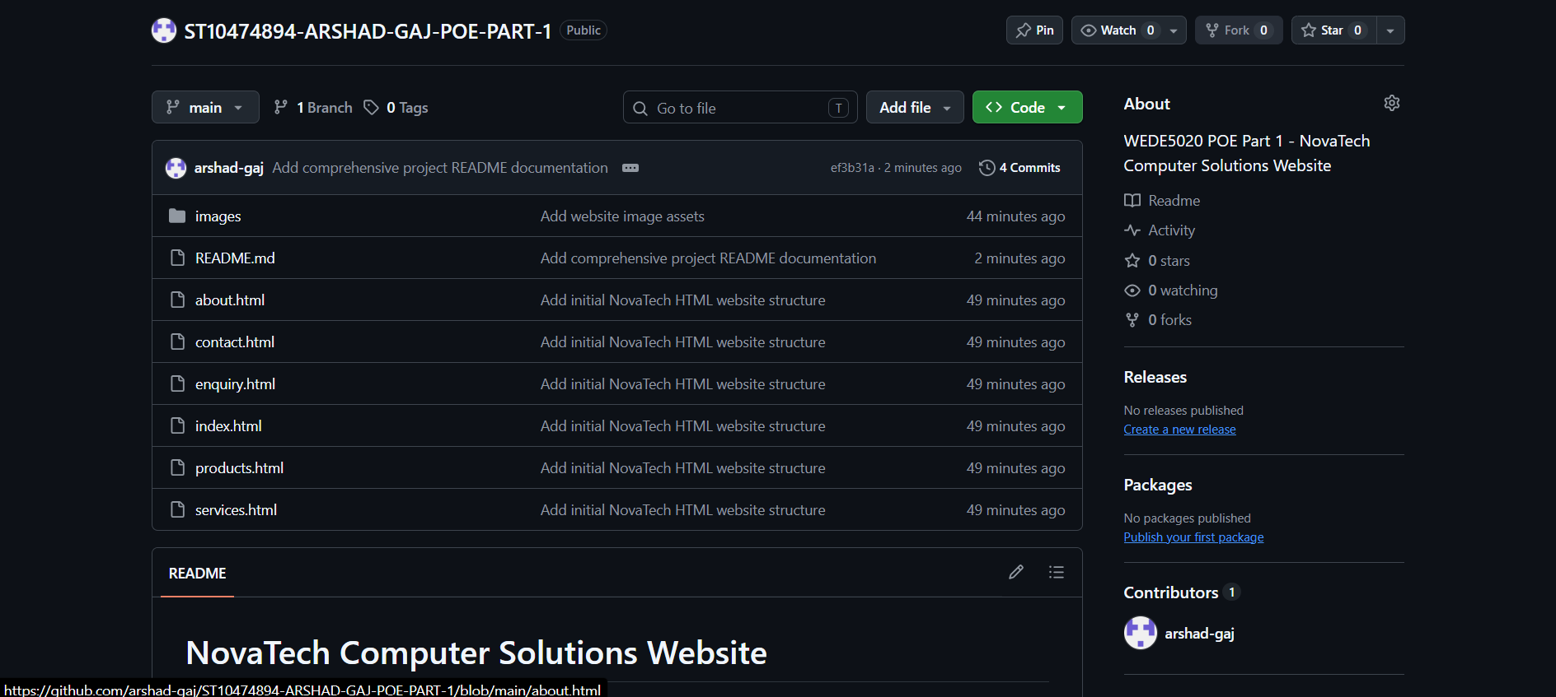

Figure 10: GitHub commit history for the NovaTech Computer Solutions website
